Final Report — Urbain Mobility Analytics Platform
AI-Driven Ministerial Decision-Support System

1. Executive Summary
The Urbain Mobility Analytics Platform is a state-of-the-art, AI-powered decision-support system designed to transform urban mobility management into a proactive, data-driven ecosystem.
By integrating real-time data ingestion, predictive analytics, machine learning, digital twin simulations, and automated MLOps pipelines, the platform enables ministries and urban authorities to anticipate congestion, optimize transportation resources, and improve strategic decision-making.
Unlike traditional traffic systems that operate reactively, the proposed solution provides predictive intelligence capable of detecting anomalies, forecasting traffic evolution, and adapting dynamically to changing urban conditions.
Key Expected Outcomes
- 25–40% reduction in city-wide congestion and travel time
- Reduction of CO₂ emissions through optimized traffic flow and green mobility strategies
- Optimization of public transport and emergency fleet allocation
- ≥95% predictive accuracy with sub-150ms NLP response latency
- Interactive “what-if” simulations through a Digital Twin environment
The platform directly contributes to:
- SDG 9 — Industry, Innovation and Infrastructure
- SDG 11 — Sustainable Cities and Communities
- SDG 13 — Climate Action

2. Urban Mobility AI Suite — Project Master Report
2.1. Problem Statement
Rapid urbanization has led to increasing traffic congestion, economic losses, environmental pollution, and reduced quality of life in modern cities.
Traditional urban traffic systems are mainly reactive and lack predictive capabilities. They often fail to handle dynamic variables such as:
- Weather conditions
- Road accidents
- Public events
- Peak-hour fluctuations
- Infrastructure anomalies
The Urbain Mobility Project addresses these limitations by introducing a real-time predictive intelligence platform capable of proactive urban traffic management.

2.2. Business Needs & Benchmarking
A benchmarking analysis of existing European smart-city solutions (SCADA systems, GPS monitoring platforms, and ITS infrastructures) highlights several limitations:
Identified Needs
- Predictive analytics instead of reactive monitoring
- Cross-departmental visibility and collaboration
- Automated AI retraining and drift management
- Advanced simulation and decision-support tools
Existing Solution Limitations
Existing Solutions | Limitations
Standard BI Tools | Lack real-time AI inference and deep learning
Legacy Traffic Systems | Static rule-based systems unable to manage anomalies
Commercial Smart-City Platforms | Expensive, vendor-locked, and difficult to customize
Proposed Added Value
The Urbain Mobility Platform introduces:
- Automated MLOps pipelines
- AI model retraining
- Reinforcement learning for adaptive traffic control
- Digital Twin simulation
- Unified ministerial command center

2.3. Proposed Solution — Ministerial AI Command Hub
The proposed solution is a centralized Command & Control Intelligence Hub designed for strategic decision-makers and ministries.
Technical Objectives
- ≥95% predictive accuracy
- Sub-150ms chatbot response latency
- Fully automated MLOps pipelines
- Real-time anomaly detection
- High availability and scalability
Business Objectives
- Reduce waiting times by at least 25%
- Optimize public transport fleet allocation
- Improve emergency response coordination
- Reduce urban carbon emissions
- Support data-driven infrastructure planning
Core Innovation
The platform integrates an interactive Digital Twin Simulator allowing ministries to test urban scenarios before real-world deployment.
Examples include:
- Weather impact simulation
- Traffic rerouting strategies
- Public event congestion analysis
- Emergency evacuation planning

2.4. Methodology
1. Data Ingestion
Multi-source data collection through Apache Airflow ETL pipelines:
- Traffic sensors
- GPS streams
- Cameras
- Weather APIs
- Public transport systems
- Event data
2. AI & Machine Learning
Hybrid AI models are used for prediction and optimization:
- XGBoost
- Random Forest
- LSTM Networks
- Transformers
- Deep Q-Networks (DQN)
3. Automation & MLOps
Automation pipelines managed through:
- Apache Airflow
- n8n workflows
- Drift detection mechanisms
- Automated retraining pipelines
4. Visualization & Decision Support
Interactive dashboards developed using:
- Angular 18
- Power BI
- Mapbox visualizations
- AI-powered chatbot assistant

2.5. Key Decision-Makers
Department | Responsibilities
🚆 Ministry of Transport | Congestion monitoring and fleet optimization
🚔 Ministry of Interior | Public safety and emergency coordination
🏛️ Urban Planning Authorities | Infrastructure planning and zoning
🌿 Ministry of Ecological Transition | Carbon footprint analysis and green mobility

2.6. Sustainable Development Goals (SDGs)
SDG 11 — Sustainable Cities and Communities
Improves urban mobility efficiency and enhances sustainability through intelligent traffic management.
SDG 13 — Climate Action
Reduces greenhouse gas emissions by minimizing congestion and idle traffic.
SDG 9 — Industry, Innovation and Infrastructure
Promotes innovation in intelligent transportation systems and smart infrastructure.

3. Architecture & Technologies
3.1. High-Level Architecture
The platform architecture is composed of multiple interconnected layers:
Data Layer
- PostgreSQL with vector support
- Time-series storage
- Real-time telemetry ingestion
Processing Layer
- Apache Airflow ETL orchestration
- Scalable processing pipelines
- Spark-ready architecture
AI/ML Layer
- TensorFlow / Keras
- PyTorch
- XGBoost
- Scikit-Learn
Orchestration Layer
- Airflow
- n8n automation workflows
- MLflow experiment tracking
Frontend Layer
- Angular 18
- Power BI integration
- Mapbox geospatial visualization
Monitoring & Security Layer
- Prometheus
- Grafana
- RBAC authentication
- MFA security
- Secure Wi-Fi Gateway

3.2. Technologies Used
Category | Technologies
Languages | Python, TypeScript, SQL
Frontend | Angular 18, RxJS
Backend | Django Ninja / FastAPI
AI & ML | TensorFlow, Keras, Scikit-Learn, XGBoost
Databases | PostgreSQL
Visualization | Power BI, Chart.js, Mapbox
Automation | Apache Airflow, n8n
Infrastructure | Docker, Kubernetes-ready
Monitoring | Prometheus, Grafana

4. Detailed System Components
4.1. AI & Machine Learning Engine (ml_engine.py)
The AI engine implements four major analytical pillars.
Classification
Used to predict discrete urban events:
- Accident risk
- Congestion level
- Emergency severity
Algorithms:
- Random Forest
- Gradient Boosting
- XGBoost
Regression
Used for continuous prediction tasks:
- Traffic volume
- Travel duration
- CO₂ emissions
Algorithms:
- XGBoost Regressor
- Neural Networks
- Lasso Regression
Clustering
Used to group urban zones with similar mobility patterns:
- KMeans
- DBSCAN
Time-Series Forecasting
Used for predictive analysis over 12–72 hours:
- SARIMA
- Prophet
- LSTM
- Transformers
Explainability
The system integrates SHAP explainability techniques to improve transparency and trust in AI predictions.

4.2. MLOps & Automation (n8n + Airflow)
The platform automates the complete AI lifecycle.
Hourly Inference Pipeline
Generates updated predictions every hour for dashboards and alerts.
Automated Retraining
Models are retrained every 6 hours to adapt to changing traffic conditions.
Drift Detection
Every 12 hours, current data distributions are compared against historical baselines.
If significant drift is detected:
- Alerts are generated
- Automatic retraining is triggered
External Webhooks
External systems can trigger workflows instantly using secure webhooks.
Notifications
Automated notifications are sent through:
- Email (SMTP)
- Slack integration

4.3. Backend API & Notifications
The backend is built with Django Ninja / FastAPI to provide high-performance APIs.
Backend Responsibilities
- API management
- ML inference execution
- Database management
- Data engineering pipelines
- Audit logging
- Retry mechanisms
Data Engineering
The backend includes preprocessing functions such as:
- Data cleaning
- Feature engineering
- Missing value handling
- Anomaly filtering

4.4. Docker Infrastructure
The infrastructure is containerized using Docker.
Main Containers
Container | Role | Port
mobility-backend | Django API Server | 8000
mobility-frontend | Angular Interface | 4200
mobility-n8n | Automation Engine | 5678
prometheus | Monitoring | 9090
grafana | Visualization & Monitoring | 3000
The architecture is fully scalable and Kubernetes-ready.

4.5. Ministerial Dashboard (Angular Frontend)
The dashboard provides an enterprise-grade visualization environment.
Features
- Real-time analytics dashboards
- Power BI embedded reports
- Interactive geospatial maps
- Scenario simulations
- KPI monitoring
- AI-powered chatbot assistant
Digital Twin Simulation
Decision-makers can simulate scenarios by modifying parameters such as:
- Weather conditions
- Traffic density
- Road closures
- Events
- Emergency situations

5. Security Report — Wi-Fi Secure Gateway
5.1. Introduction
Protecting sensitive ministerial data is a critical requirement.
The Wi-Fi Secure Gateway ensures that only authorized users connected to a dedicated secure Wi-Fi network can access the platform.
This mechanism creates both:
- A physical security layer
- A logical access-control layer
It is particularly suitable for:
- Government command centers
- Secure meeting rooms
- Strategic operations environments

5.2. Security Architecture
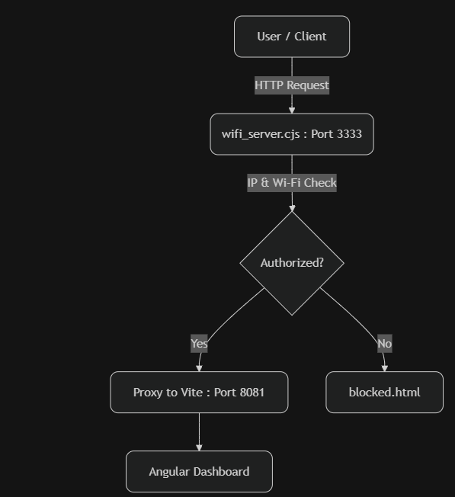

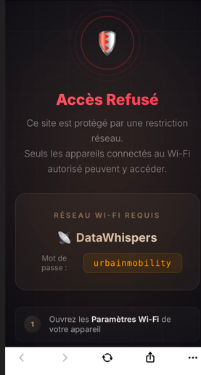

Main Components
Component | Role
create_wifi.py | Creates the secure hotspot dynamically
wifi_server.cjs | Node.js reverse proxy and gateway
blocked.html | Premium access-denied interface
wifi_config.json | Centralized Wi-Fi configuration
start_secure.bat | One-click secure environment launcher

5.3. Verification Mechanisms
The gateway applies multiple verification layers for every request.
Localhost Verification
Allows automatic access from the host machine.
SSID Verification
Checks whether the client is connected to the authorized Wi-Fi network.
IP Range Validation
Confirms that the client IP belongs to the secure hotspot range.
Development Bypass
A controlled --bypass mode is available for testing purposes.

5.4. User Experience (UX)
Authorized Users
Users connected to the secure network access the platform seamlessly.
Unauthorized Users
Unauthorized users are redirected to a professional dark-mode blocked.html page displaying:
- Access restrictions
- Required SSID
- Connection instructions

5.5. Deployment & Execution
The secure environment can be launched through start_secure.bat.
Startup Workflow
- Administrator privilege verification
- Secure hotspot creation
- Frontend server launch
- Security gateway startup
- Real-time access monitoring
Extensibility
The secure gateway can also be deployed on:
- Raspberry Pi
- Mini-PC devices
- Portable secure command stations

Conclusion
The Urbain Mobility Analytics Platform transforms raw urban data into actionable strategic intelligence.
The platform combines:
- Artificial Intelligence
- Predictive Analytics
- Automated MLOps
- Real-Time Monitoring
- Digital Twin Simulation
- Advanced Security Infrastructure
Through continuous retraining, drift detection, and scalable cloud-ready architecture, the system provides ministries and urban authorities with a powerful intelligent command center for the cities of tomorrow.
The solution is proactive, adaptive, scalable, secure, and aligned with the future vision of sustainable smart cities.

